**PROCESS INSTRUMENTATION**

**Name: Vivek Chandrashekhar Rugale**

**GR No.: 11810369**

**Div.: TY-C**

**Roll No.: 24 (Batch B1)**

**LAB 6:**

**Aim – Study of flow totalizer and its implementation**

Implementation of flow totalizer logic in Python:

For constant flow-

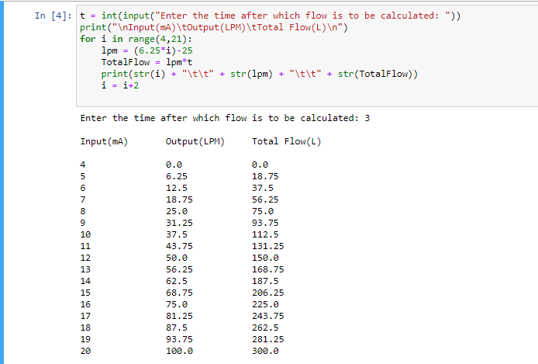

For variable flow-

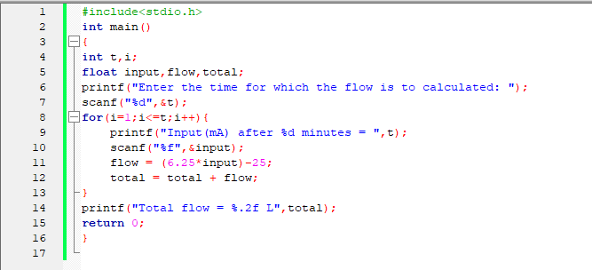

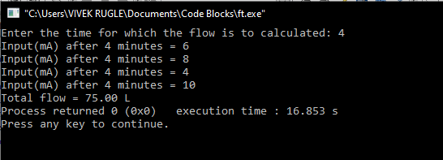

**Conclusion:**

Studied the flow totalizer logic and implemented it using Python. For variable flow, flow is calculated at each unit time and then added.